Week | News Story | Focus question | UN Article | UN Link | British Value Link
17th  April | Loud siren like sounds will be triggered on mobile phones and other devices on 23rd April as part of a UK Government test of its new emergency alerts system. | What can we practise in case there is ever an emergency? | 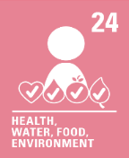 | We all have the right to live in a safe environment. Emergency alerts is one way that can help us to stay safe. | Individual Liberty - There are many situations in life that can become dangerous. Practising fire drills and knowing how to call the emergency services will help us if there is an emergency.
24th  April | An educational television programme for young people in Afghanistan has been launched by the BBC. | How do you learn best? | 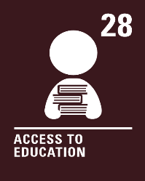 | We all have the right to an education. Primary education should be free. Secondary and higher education should be available to every child. We should be encouraged to go to school to the highest level possible. | Rule of Law - Different countries have different rules and laws about school and education. In the UK, all children must be provided with an education from age 5 to 18.
1st  May | The coronation of King Charles III is taking place at Westminster Abbey on Saturday 6th May. | How do you like to celebrate? | 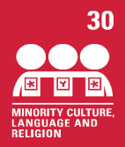 | We all have the right to use our own language, culture and religion even if these are not shared by most people in the country where we live. | Mutual Respect and Tolerance - We are all different; our lives, and our beliefs. How or if we choose to celebrate the coronation will  be different too and we respect this.
8th  May | For the first time since 1998, the United Kingdom will play host to the Eurovision Song Contest and will do so on behalf of last year’s winners, Ukraine, who are unable to host due to the ongoing war. | How can music help us? | 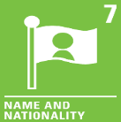 | The Eurovision Song Contest brings together many different nations.  We all must have a nationality (belong to a country). | Democracy - We all have a voice. We can use our voice to choose our favourite song in the Eurovision Song Contest. We may even cast a vote!
15th  May | Blackpool Zoo is looking to hire a team of people in an attempt to scare away nuisance seagulls by dressing them in bird costumes. | Should all animals be treated the same? | 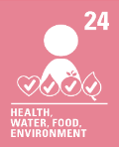 | We have the right to live in a clean and safe environment. Sometimes animals may damage our clean and safe environment, so measures need to be put in place to prevent this. | Mutual Respect and Tolerance – Seagulls are known for stealing food and can be a nuisance! Not everyone will feel this way. We can show respect to people who have different beliefs and opinions.
22nd  May | 30 years ago, on 30th April 1993, Swiss science company CERN opened up the World Wide Web to the world, free-of-charge. | How can we stay safe online? | 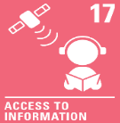 | We all have the right to get information from the World Wide Web and other sources. Adults should make sure we are safe when using the World Wide Web. | Individual Liberty - Being able to find out information is a right we all have. Using the World Wide Web can help us do this, but we must make sure we keep ourselves safe whilst we are online.

