NURSERY LONG TERM PLAN – LITERACY 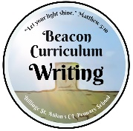 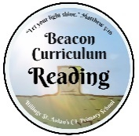
Autumn 1 | Autumn 2 | Spring 1 | Spring 2 | Summer 1 | Summer 2
Understand the five key concepts about print:  - print has meaning - the names of the different parts of a book  - print can have different purposes - page sequencing  - we read English text from left to right and from top to bottom  This Photo by Unknown Author is licensed under CC BY-NC | Develop their phonological awareness, so that they can:  - spot and suggest rhymes  - count or clap syllables in a word  - recognise words with the same initial sound, such as money and mother.  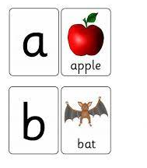 | Engage in extended conversations about stories, learning new vocabulary.  This Photo by Unknown Author is licensed under CC BY | Use some of their print and letter knowledge in their early writing. For example: writing a pretend shopping list that starts at the top of the page; write ‘m’ for mummy.  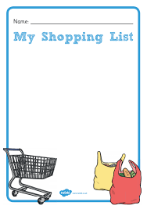 | Write some or all of their name.  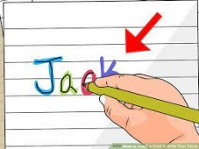 | Write some letters accurately.  