RECEPTION LONG TERM PLAN – LITERACY (READING) 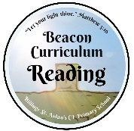
Autumn 1 | Autumn 2 | Spring 1 | Spring 2 | Summer 1 | Summer 2
Read individual letters by saying the sounds for them.  Blend sounds into words, so that they can read short words made up of known letter-sound correspondences.  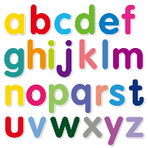 | Read some letter groups that each represent one sound and say sounds for them.  Read a few common exception words matched to the school’s phonic programme.  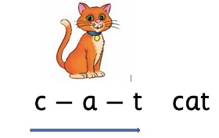 | Say a sound for each letter in the alphabet and at  least 10 digraphs.  Read a few common exception words matched to the school’s phonic programme. | Read simple phrases and sentences made up of words with known letter–sound correspondences and, where necessary, a few exception words. | Read aloud simple sentences and books that are consistent with their phonic knowledge, including  some common exception words. | Read aloud simple sentences and books that are consistent with their phonic knowledge, including  some common exception words.

