Week | News Story | Focus Question | UN Article | UN Link | British Value Link | Protected Characteristics
17th April | Loud siren like sounds will be triggered on mobile phones and other devices on 23rd April as part of a UK Government test of its new emergency alerts system. | Can you prepare for emergency situations? | 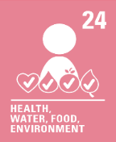 | We all have the right to live in a safe environment. The emergency alert is one way that can help us stay safe. | Individual Liberty - There are many situations in life that can become dangerous. By considering the consequences of our actions and managing risks, we can help to keep ourselves and others safer. | Religion or Belief - Some people will not receive emergency alerts because they do not have mobile phones or other devices. There are other ways people can be alerted so everyone can be kept as safe as possible.
24th April | An educational television programme for young people in Afghanistan has been launched by the BBC. | How do you learn best? | 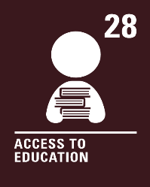 | We all have the right to an education. Primary education should be free. Secondary and higher education should be available to every child. We should be encouraged to go to school to the highest level possible. | Rule of Law - Different countries have different rules and laws about school and education. In the UK, all children must be provided with an education from age 5 to 18. | Sex - In Afghanistan, girls over 11 years of age are not allowed to attend school. Being a boy or a girl should never stop us from doing something or cause us to be treated unfairly.
1st  May | The coronation of King Charles III is taking place at Westminster Abbey on Saturday 6th May. | How do you choose to celebrate significant events? | 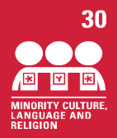 | We all have the right to use our own language, culture and religion even if these are not shared by most people in the country where we live. | Mutual Respect and Tolerance - We are all different; our lives, and our beliefs. How or if we choose to celebrate the coronation will be different too and we respect this. | Religion or Belief - The coronation service, where King Charles III will be crowned king, is a Christian service. However, it will reflect the different religions and diversity of modern Britain. Our religion or belief should never stop us being invited to take part in coronation celebrations.
8th  May | For the first time since 1998, the United Kingdom will play host to the Eurovision Song Contest and will do so on behalf of last year’s winners, Ukraine, who are unable to host due to the ongoing war. | Do you think music has a positive impact on the world? | 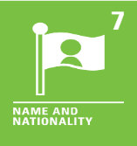 | The Eurovision Song Contest brings together many different nations. We all must have a nationality (belong to a country). | Democracy - We all have a voice. We can use our voice to choose our favourite song in the Eurovision Song Contest. We may even cast a vote! | Race - Whatever our nationality, we should be able to enjoy watching the Eurovision Song Contest, if we choose to.
15th May | Blackpool Zoo is looking to hire a team of people in an attempt to scare away nuisance seagulls by dressing them in bird costumes. | Should all animals be treated equally? | 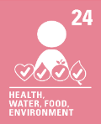 | We have the right to live in a clean and safe environment. Sometimes animals may damage our clean and safe environment, so measures need to be put in place to prevent this. | Mutual Respect and Tolerance - Seagulls are known for stealing food and can be a nuisance! Not everyone will feel this way. We can show respect to people who have different beliefs and opinions. | Religion or Belief - A person’s religion or belief can impact their regard for certain animals. This should never cause us to be treated unfairly.
22nd May | 30 years ago, on 30th April 1993, Swiss science company CERN opened up the World Wide Web to the world, free-of-charge. | Has being online changed things for the better? | 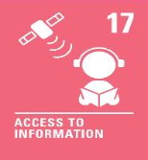 | We all have the right to get information from the World Wide Web and other sources. Adults should make sure we are safe when using the World Wide Web. | Individual Liberty - Having access to information is a right we all have. Using the World Wide Web can have many benefits but also risks. We can manage the risks and help to keep ourselves safe whilst using it. | Age - We should all be able to access the World Wide Web, no matter what age we are. Sometimes there may be age restrictions in place but they are to help keep us safe.

