Week | News Story | Focus Question | UN Article | UN Link | British Value Link | Protected Characteristics
29th  May | A new project announced by the Greek government hopes to make hundreds of the country’s beaches wheelchair accessible by installing remote operated ramps and making toilets accessible to all. | Could your local area be more inclusive? | 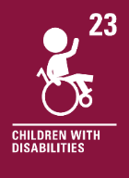 | Every child with a disability should enjoy the best possible life in society. Governments should remove all obstacles for children with disabilities to become independent and to participate actively in the community. | Mutual Respect and Tolerance - We know that life is not the same for everyone. Accessing places can be much more difficult for some people. It is important to understand and respect the needs and feelings of others. | Disability - Wheelchair users may find some places, like the sea, difficult to access. We can all be responsible for being aware of difficulties others face and helping to make an inclusive world.
5th  June | Ahead of World Environment Day on 5th June, a new report from the United Nations Environment Programme (UNEP) has announced that countries could cut plastic pollution by 80% in fewer than 20 years. | Is it better to reuse or recycle? | 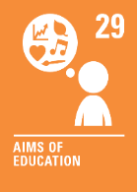 | One of the aims of our education is to help us protect the environment. Learning more about World Environment Day can help us do this. | Rule of Law - In some countries, there are laws that ban certain single-use plastics. This is to help care for and protect our environment. | Religion or Belief - Our concern for the environment can affect how we live our life. This can form part of our beliefs. We should never be treated unfairly because of our beliefs.
12th  June | 13-year-old Max Woosey - also known as the ‘Boy in the Tent’ has recently set a Guinness World Record for the most money raised by camping. Inspired by a family friend, the young teenager has raised over £750,000 for North Devon Hospice. | What is the best way to show your support? | 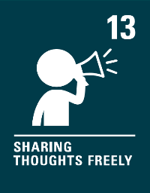 | We have the right to share freely with others what we learn, think or feel unless it harms other people. | Individual Liberty - We all have the right and freedom to raise awareness of the things that are important to us. We should consider how we choose to do this and the impact it may have on others. We can all make a positive difference! | Age - Max was 10 years old when he took on his challenge. We can all set ourselves goals and challenges and achieve amazing things. Nobody should judge, underestimate or treat anyone unfairly because of their age.
19th  June | Within the next ten years, people may be able to travel between London and Sydney in just two hours by journeying through space on a sub-orbital flight. | How has travel changed our lives? | 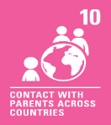 | If a child lives in a different country than their parents, governments must let the child and parents travel so that they can stay in contact and be together. | Mutual Respect and Tolerance - Having access to travel can help us learn more about people living in our world. Life is not the same for everyone and  we should respect that. | Religion or Belief - Where and how people choose to live may affect the modes of transport they use. We should never be treated unfairly because of how we choose to live.
26th  June | Four children have been found alive after surviving a plane crash and spending forty days alone in Colombia's Amazon jungle. | What is bravery? | 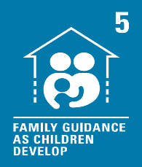 | Governments should let families and communities guide their children as they grow up. The Huitoto traditionally learn hunting, fishing and gathering from a young age. | Individual Liberty - There are some situations or challenges we face that may be tricky. Learning how to manage risks can help us make choices and take action in response to these. | Race - Race can mean your colour, nationality or your ethnic or national origins. The Huitoto are an indigenous group whose traditional land is around the Southern Colombian city of Leticia. We should never be treated unfairly because of our race.
3rd  July | A new UK government campaign hopes to encourage young people to ‘respect, protect and enjoy’ the countryside. | Should everyone learn the Countryside Code? | 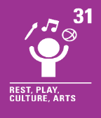 | The Countryside Code provides guidelines to help us protect and care for the countryside whilst we enjoy it to rest, relax or play. We all have the right to rest, relax and play. | Mutual Respect - The Countryside Code helps us all to work together as a society, to do the right actions for both people and places. | Age - Everybody should feel welcome in the countryside and other green spaces, no matter what age we are.
10th  July | The world-famous Wimbledon tennis tournament is currently underway and will conclude on 16th July. | Should you always want to win? | 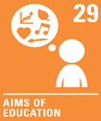 | Our education should help us to fully develop our personalities, talents and abilities. Whilst doing this, there will be times when we win and times when we lose. We can learn so much from both! | Mutual Respect and Tolerance - Our behaviour, actions and words affect others. We can show respect to ourselves and each other, whether we win or lose. | Race - Tennis players from all over the world compete at Wimbledon. Someone’s colour, nationality or ethnic or national origins should never be the reason they are unable to compete.
17th  July | Austrian artist Gustav Klimt’s final portrait has become the most expensive artwork ever auctioned in Europe. | What makes art valuable? | 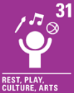 | We all have the right to take part in cultural and creative activities. Enjoying artworks by others or creating our own can help us do this. | Mutual Respect and Tolerance - Artwork can mean different things to different people. We can show respect to others and the things they value, even if these are different from our own. | Religion or Belief - Our religion and/or beliefs affect our life choices or the way we live our life. Some artworks have meaning because they represent beliefs. We should never be treated unfairly because of our beliefs.

